Travel Health Advice Leaflet

The following information will help you to stay healthy on your trip.
Please make sure you read it following on from your appointment with us.


WATER
Diseases can be caught from drinking contaminated water, or swimming in it. Unless you know the water supply is safe where you are staying,
ONLY USE (in order of preference)
- Boiled water
- Bottled water or canned drinks
- Water treated by a sterilising agent.
This includes water used to make ice cubes in drinks and water for cleaning your teeth

SWIMMING
It is safer to swim in water that is well chlorinated. If you are travelling to Africa, South America or some parts of the Caribbean, avoid swimming in fresh water lakes and streams. You can catch a parasitic disease called schistosomiasis from such places. This disease is also known as Bilharzia. It is also wise never to go barefoot, but to wear protective footwear when out, even on the beach. Other diseases can be caught from sand and soil, particularly wet soil.

FOOD
Contaminated food is the commonest source of many diseases abroad. You can help prevent illness by following these guidelines for advice on consuming food and beverages:

Category | SAFE | PROBABLY SAFE | UNSAFE
Beverages | - Carbonated soft drinks  - Carbonated water  - Boiled water  - Purified water (iodine or chlorine) | - Fresh citrus juices  - Bottled water  - Packaged (machine - made ice) | - Tap water  - Chipped ice  - Unpasteurized milk
Food | - Hot thoroughly grilled, boiled  - Processed and packaged  - Cooked vegetables and peeled* fruits | - Dry items  - Hyperosmolar items (such as jam and syrup)  - Washed vegetables and fruit | - Salads  - Sauces and ‘salsa’  - Uncooked seafood  - Raw or poorly cooked meats  - Unpeeled* fruits  - Unpasteurized dairy products  - Cold desserts
Setting | Recommended  restaurants | Local homes | Street vendors
Reference: Ericsson, C.D. (2019) Prevention of Travelers Diarrhea. In: Keystone, J. (ed.) Travel Medicine. London:
Elsevier, pp. 199 – 204

*Peeled fruits for example bananas: Unpeeled fruits for example, raspberries, strawberries.
Another source of calories is alcohol! If you drink to excess, alcohol could lead you to become carefree and ignore these precautions.

PERSONAL HYGIENE
Many diseases are transmitted by what is known as the ‘faecal-oral’ route. To help prevent this, always wash your hands with soap and clean water after going to the toilet, before eating and before handling food. Using hand gel is another sensible option.

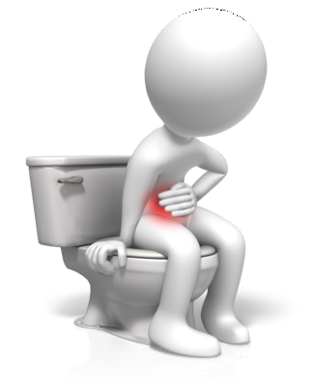
TRAVELLERS’ DIARRHOEA
This the most common illness that you will be exposed to abroad and there is
NO vaccine against it. Diarrhoea is caused by eating and/or drinking food
and water contaminated by bacteria, viruses or parasites. Risk of illness is higher in some countries than others.
High risk areas include North Africa, sub-Saharan Africa, the Indian Subcontinent,
S.E. Asia, South America, Mexico and the Middle East.
Medium risk areas include the northern Mediterranean, Canary Islands and the Caribbean Islands.
Low risk areas include North America, Western Europe and Australia
You can certainly help prevent travellers’ diarrhoea in the way you behave - make sure you follow the food, water and personal hygiene guidelines already given.

What is travellers’ diarrhoea?
Travellers’ diarrhoea is 3 or more loose stools in a 24 hour period often accompanied by stomach pain, cramps and vomiting. It usually lasts 2-4 days and whilst it is not a life threatening illness, it can disrupt your trip for several days. The main danger of the illness is dehydration, and this, if very severe, can kill if it is not treated. Treatment is therefore rehydration. In severe cases and particularly in young children and the elderly, commercially prepared rehydration solution is extremely useful.

Travel well prepared
A good tip is to take oral rehydration solutions with you. These can be bought over the counter in a chemist shop, available in tablet or sachet form — for example:
DIORALYTE or ELECTROLADE or DIORALYTE RELIEF. (The latter is a formula containing rice powder which also helps to relieve the diarrhoea, particularly useful in children). Prepare according to instructions. Take care regarding their use in very small children and seek medical advice where necessary.
Anti diarrhoeal tablets can be used for adults but should NEVER be USED in children under 4 years of age, and only on prescription for children aged 4 to 12 years. Commonly used tablets are loperamide and bismuth subsalicylate - ask you pharmacist for advice about them.

None of these tablets should ever be used if the person has a temperature or blood in the stool.
Do contact medical help if the affected person has:-
- A temperature
- Blood in the diarrhoea
- Diarrhoea for more than 48 hours (or 24 hours in children)
- Becomes confused
In some rare circumstances, antibiotics are used as a standby treatment for travellers’ diarrhoea. Such medication is not usually available on the NHS in anticipation of you being ill when away and needs to be prescribed. A woman taking the oral contraceptive pill may not have full contraceptive protection if she has had diarrhoea and vomiting. Extra precautions must be used - refer to your ‘pill’ information leaflet. If using condoms, take a supply of good quality ones with you which are CE approved.

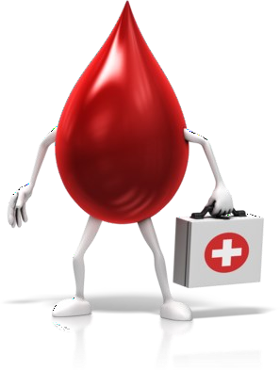
HEPATITIS B and HIV INFECTION - these diseases can be transmitted by
- Blood transfusion
- Medical procedures with non-sterile equipment
- Sharing of needles (e.g. tattooing, body piercing, acupuncture and drug abuse)
- Sexual contact — Sexually transmitted infections or STIs are also transmitted this way

Ways to protect yourself
- Only accept a blood transfusion when essential
- If travelling to a resource poor country, take a sterile medical kit
- Avoid procedures e.g. ear and body piercing, tattooing & acupuncture
- Avoid casual sex, especially without using condoms

Remember! Excessive alcohol can make you carefree and lead you to take risks you otherwise would not consider.

INSECT BITES
Mosquitoes, certain types of flies, ticks and bugs can cause many different diseases. e.g. malaria, dengue fever, yellow fever. Some bite at night, but some during daytime so protection is needed at all times.

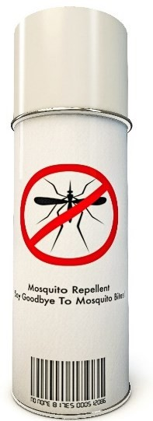
Avoid being bitten by:
- Covering up skin as much as possible if going out at night, (mosquitoes that transmit malaria bite from dusk until dawn). Wear loose fitting clothes, long sleeves, trousers or long skirts.
- Use insect repellents on exposed skin. (DEET containing products are the most effective. A content of up to 50% DEET is recommended for tropical destinations). Clothes can be sprayed with repellents too or clothing specific sprays e.g. permethrin. Check suitability for children on the individual products, although National Guidance states DEET products can be used on infants from 2 months of age. If using sunscreen always apply first, followed by an insect repellent spray on top.
- If room is not air conditioned, but is screened, close shutters early evening and spray room with knockdown insecticide spray. In malarious regions, if camping, or sleeping in unprotected accommodation, always sleep under a mosquito net (impregnated with permethrin). Avoid camping near areas of stagnant water, these are common breeding areas for mosquitoes etc.
- Electric insecticide vaporisers are very effective as long as there are no power failures!
- There is no scientific evidence that electric buzzers, savoury yeast extract, tea tree oil, bath oils, garlic and vitamin B are effective.
- Homeopathic and herbal medications should NEVER be used as an alternative to conventional measures for malaria prevention.

MALARIA
Malaria is a disease spread by mosquitoes, there is no vaccine yet available. If you are travelling to a malarious country, the travel adviser will have given you a separate leaflet with more details, please read it. Remember malaria is a serious and sometimes fatal disease. If you develop flu like symptoms, including fever, sweats, chills, feeling unwell, headaches, muscle pains, cough, diarrhoea – then seek medical help immediately for advice and say you’ve been abroad. This is VITAL, don’t delay.
Remember the ABCD of malaria prevention advice:
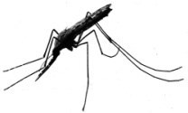
Awareness of the risk
Bite prevention
Chemoprophylaxis (taking the correct tablets)
Diagnosis (knowing the symptoms and acting quickly)

ANIMAL BITES
Rabies is present in many parts of the world. If a person develops rabies, death is 100% certain.

THERE ARE 3 RULES REGARDING RABIES
- Do not touch any animal, even dogs and cats
- If you are licked on broken skin, scratched or bitten by an animal in a country which has rabies, wash the wound thoroughly with soap and running water for 10 - 15 minutes, then apply an antiseptic solution if possible e.g. iodine or alcohol. Such precautions also apply if you are licked by the animal with their saliva coming into contact with your eyes or inside your mouth (essentially any mucous membranes)
- Seek medical advice IMMEDIATELY, even if you have been previously immunised, this is absolutely essential See this video on YouTube about rabies. https://youtu.be/xj-d7l0EV28

ACCIDENTS
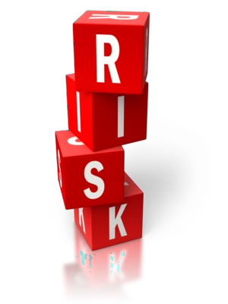
Major leading causes of death in travellers abroad are due to accidents, predominantly road traffic accidents and swimming/water accidents. You can help prevent them by following sensible precautions

PRECAUTIONARY GUIDELINES
  - Avoid alcohol and food before swimming
  - Never dive into water where the depth is uncertain
  - Only swim in safe water, check currents, sharks, jellyfish etc.
  - Avoid alcohol when driving, especially at night
  - Avoid hiring motorcycles and mopeds
  - If hiring a car, rent a large one if possible, ensure the tyres, brakes and seat belts are in good condition
  - Use reliable taxi firms, know where emergency facilities are

PERSONAL SAFETY AND SECURITY
The Foreign, Commonwealth and Development Office (FCDO) provide excellent information
about this. They have information for many different types of travel and also advise on travel to specific destinations in times of political unrest and natural disasters. Please go to their website for more information at https://www.gov.uk/foreign-travel-advice and look at the country specific information.

INSURANCE COVER
- Take out adequate insurance cover for your trip. This should possibly include medical repatriation as without it, this service is extremely expensive if needed.
- If you have any pre existing medical conditions, make sure you inform the insurance company of these details and check the small print of the policy thoroughly.
- Since the UK left the European Union, there has been an introduction of a Global Health Insurance Card or GHIC as the EHIC is being phased out. See the NHS website for more information about this.
- Please note, additional travel insurance is still advised even if you have an EHIC card. See TravelHealthPro

AIR TRAVEL
It is sensible on any long haul flight to be comfortable in your seat. Exercise your legs, feet and toes while sitting every half an hour or so and take short walks whenever feasible. Upper body and breathing exercises can further improve circulation. Drink plenty of water and be sensible about alcohol intake which in excess leads to dehydration. Further information can be obtained from the websites detailed at the end of this leaflet with more specific advice and information on travel-related deep vein thrombosis.

SUN AND HEAT
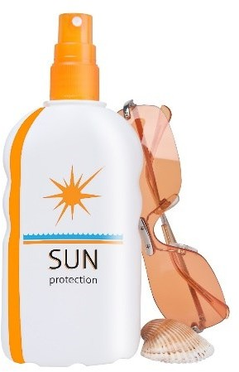
Sunburn and heat-stroke cause serious problems in travellers but in the long term can be a serious cause of skin cancer. There is no such thing as a safe suntan, but the following advice should be taken: PRECAUTIONARY GUIDELINES
- Increase sun exposure gradually, with a 20 minute limit initially.
- Use sun blocks which contain both UVA and UVB protection and sufficient sun protection factor (SPF) and a minimum of SPF 15. Children under 3 years should have a minimum of SPF 25 and babies under 6 months should be kept out of the sun at all times. Reapply often and always after swimming and washing. Read manufacturer instructions
- Always apply sunscreen first followed by an insect repellent spray on top
- Wear protective clothing – sunhats, T shirts and sunglasses etc.
- Avoid going out between 11am - 3pm, when the sun’s rays are strongest
- Take special care of children and those with pale skin/red hair

- Drink extra fluids in a hot climate – be aware alcohol can make you dehydrated

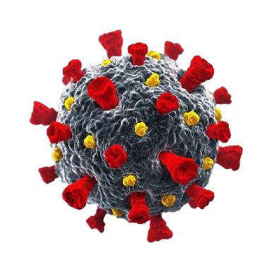
COVID-19 (last but not least!)
Make sure you are aware of websites to help you determine the risk if any at your destination, as found in the table of resources below. Remember back to the precautions you took when COVID-19 advice was followed by many and use your common sense to assess your situation and actions. Remember, do not touch your eyes, nose or mouth if your hands are not clean. Wash your hands with soap and water or use hand sanitiser regularly throughout the day, especially after you
cough, sneeze or blow your nose, and before you eat or handle food. Don’t forget to pack your sanitising hand gel and possibly some face masks to use if you find yourself in a crowded unsafe situation while you’re away.

Here are some examples of interesting website addresses for more general information:

Name/description | Web address
- Easy to access resources in one place from Jane Chiodini  (author of this leaflet) | https://www.janechiodini.co.uk/help/tar/
- NaTHNaC - National Travel Health Network and Centre England based, with similar information to above | http://travelhealthpro.org.uk/
- NHS – look at the A-Z and also search for specific topics  e.g. jetlag. Excellent general website also. | https://www.nhs.uk/conditions/travel-  vaccinations/
- FCDO – Foreign, Development & Commonwealth Office, especially useful and look at ‘related content’ links on each country specific page | https://www.gov.uk/foreign-travel- advice
- Sunsmart - is the Cancer research website providing information about skin cancer and sun protection advice | www.sunsmart.org.uk
- Carbon Monoxide alarm – read the back story in a blog and all about the Hudson Pack Safe Appeal | https://www.safelincs.co.uk/travel-co-  detector-with-strap/
- Medex – Useful advice booklet on ‘travelling at high altitude’ | https://www.medex.org.uk/the-  medex-book/
- Medic Alert® - life-saving identification system for individuals with hidden medical conditions and allergies | www.medicalert.org.uk
- Hidden Disabilities Sunflower – products and information to voluntarily share a disability or condition that may not be immediately apparent | https://hdsunflower.com/uk/
- Diabetes UK – information specific for those with diabetes who wish to travel | https://www.diabetes.org.uk/guide-to-  diabetes/life-with-diabetes/travel
- ILGA: selection of maps, e.g. legal gender recognition | https://ilga.org/ilga-world-maps
- Global travel clinic locator from the International Society of Travel Medicine | www.istm.org
- Google translate – Free online translation service | http://translate.google.com
- COVID specific  - UK Government COVID-19 page includes a travel section  - FCDO – look at coronavirus section for each country  - COVID-19: General Advice for Travellers from NaTHNaC and TRAVAX | https://www.gov.uk/coronavirus https://www.gov.uk/foreign-travel-advice NaTHNaC on TravelHealthPro
- Travel insurance explained  - Best travel insurance if you have a medical condition | Which?  Tips from Which?

Have a good, but safe and healthy trip!

